C180 -185L High Heat Sterilization CO2 Incubator Stainless Steel

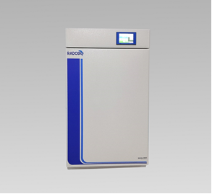

Use
For static culture of cell , it’s high heat sterilization CO2 incubator with HEPA filter.

Performance
- 4.3 inch LCD touch screen, intuitive control easy to operate.
- 304 frosted stainless steel arc angle integrated inner cavity, beautiful and easy to clean.
- Internal six-sided direct heating system ensures temperature uniformity.
- HEPA air filtration continuously removes particulates for Class ISO 5 level quality conditions.
- HEPA filter and IR sensor are easily removed.
- 140°C high heat sterilization ensure internal clean.
- Circulating airflow technology ensures high consistency of culture conditions in the chamber.
- Clean humidified pan to maintain culture humidity environment.
- After stable operation, if the temperature fluctuation exceeds the set value plus or minus overtemperature alarm deviation, audible alarm activates.
- Audible alarm activates if outer door is opened over 1 minute.
- Historical data can be viewed in real time，and can be exported by the USB interface.

Technical Details

Model | C180
Control interface | 4.3 inch LCD touch screen
Temperature control mode | PID control mode
Temperature control range | Ambient +5°C~60°C
Temperature display resolution | 0.1°C
Temperature fluctuation | ±0.1°C
Temperature field uniformity | ±0.3°C @37°C
Power of heating | 900W
Timing function | 0-999.9hours
Internal size | L541 x W508 x H681mm
External size | L660 x W640 x H1000mm
Volume | 185L
Principle of CO2 sensor | IR sensor detection
CO2 control range | 0-20%
CO2 display resolution | 0.10%
CO2 supply | 0.05~0.1MPa is recommended
HEPA filtering | ISO 5 level, 5 minutes
Sterilization | 140°C High heat sterilization
Maximum expansion | Up to 2 units can be stacked
Ambient temperature | 5°C~ 40°C
Power supply | 115V~230V±10%, 50~60Hz
Weight | 108kgs
Optional accessories
HEPA filter
Access Port filter

