C240N UV Sterilization CO2 Incubator
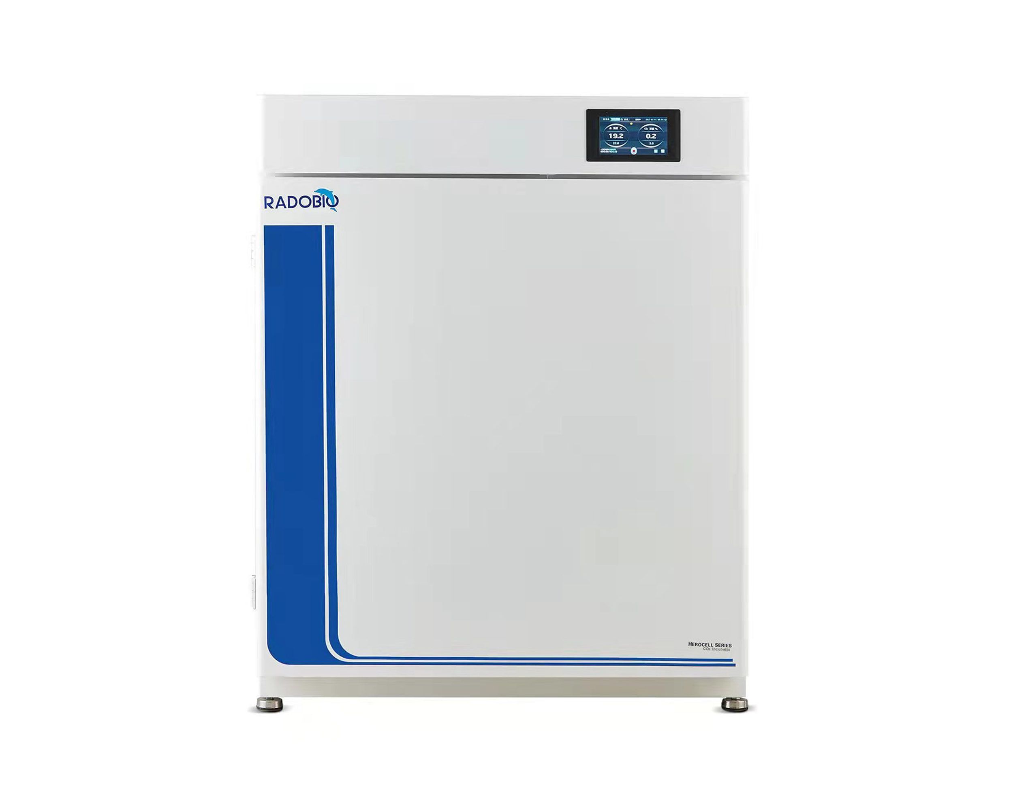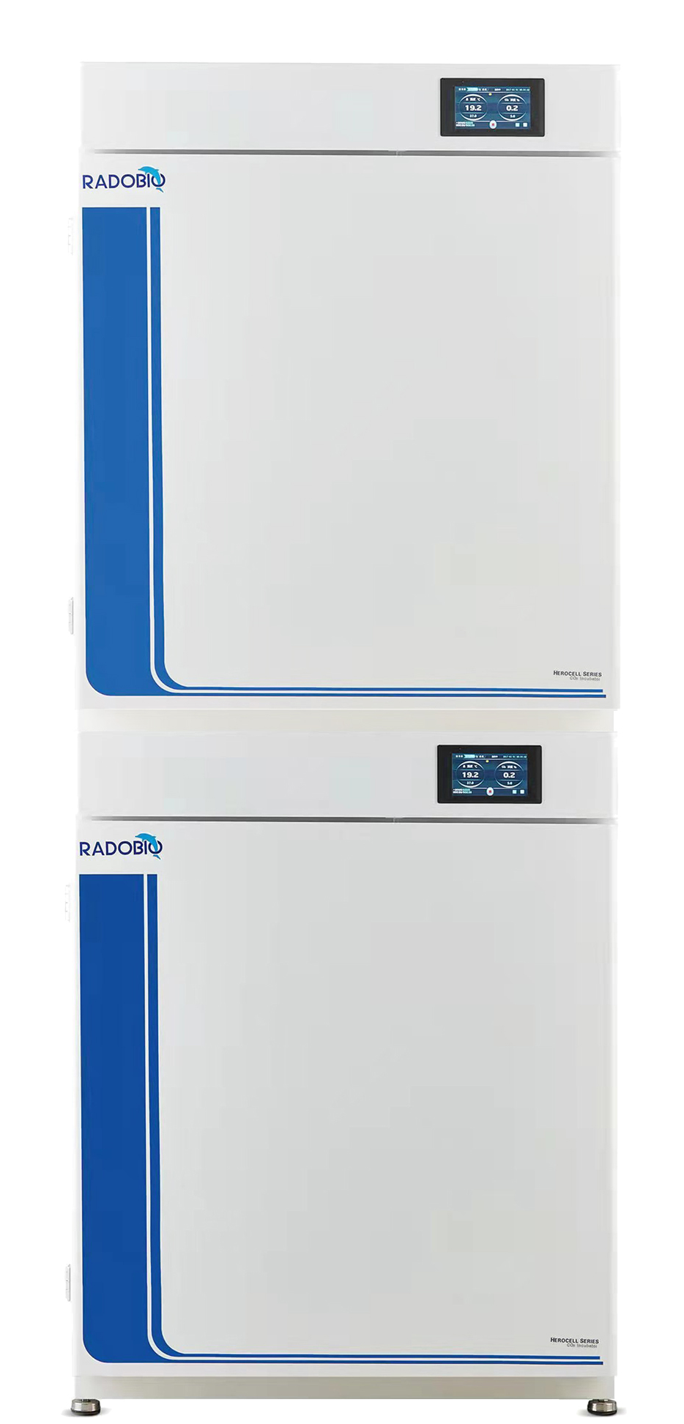
C240N C240N-2 C240N-D2

Models：

Cat.No. | Product name | Number of unit | Dimension(L x W x H)
C240N | UV Sterilization CO2 Incubator | 1 Unit（1Unit） | 800×652×1000mm ( Base included)
C240N-2 | UV Sterilization CO2 Incubator(Double Units） | 1 Set（2 Units） | 800×652×1965mm ( Base included)
C240N-D2 | UV Sterilization CO2 Incubator(the Second Unit） | 1 Unit（2nd Unit） | 800×652×965mm

Use:

For static culture of cell , it’s UV sterilization CO2 incubator with HEPA filter.

Key Features:

❏ 6-side direct heat chamber
▸ Large 248L capacity chamber provides large enough culture space and ideal environment for cell culture applications
▸ The 6-side heating method, with efficient, high-performance heating systems distributed on the surface of each chamber, provides a highly uniform temperature distribution throughout the incubator, resulting in a more uniform temperature throughout the incubator and a uniform temperature field of ±0.3°C within the chamber after stabilization
▸ Standard right side door opening, left and right door opening direction according to demand
▸ Polished stainless steel one-piece interior chamber with rounded corners for easy cleaning
▸ Flexible combination of detachable pallets, independent humidity pan can be removed or put in according to demand
▸ Built-in fan in the chamber gently blows air for even distribution within the chamber, ensuring a consistent culture environment
▸ Stainless steel shelves and brackets are durable and can be removed without tools in 1 minute

❏ 304 stainless steel water pan for humidification
▸ Easy-to-clean 304 stainless steel water pan holds up to 4L of water, ensuring a high humidity environment in the culture chamber. It provides maximum protection for cell and tissue culture and avoids the dangerous formation of condensation, even when the humidity pan generates high humidity at normal room temperature, and is still less likely to generate condensation above the chamber. Turbulence-free chamber ventilation ensures a constant and uniform cell culture environment

❏ UV sterilization
▸ UV sterilization provided as needed simplifies cleaning and eliminates the need for autoclaving and reassembling components separately, effectively improving work efficiency

❏ ISO Class 5 HEPA filtered airflow system
▸ Chamber's built-in HEPA air filtration system provides uninterrupted filtration of air throughout the chamber
▸ ISO Class 5 air quality within 5 minutes of closing the door
▸ Provides continuous protection by reducing the ability of airborne contaminants to adhere to interior surfaces

❏ Infrared (IR) CO2 sensor for accurate monitoring
▸ Infrared (IR) CO2 sensor for stable monitoring when humidity and temperature are less predictable, effectively avoiding measurement bias problems associated with frequent door opening and closing
▸ Ideal for sensitive applications and remote monitoring, or where frequent opening of the incubator is required
▸ Temperature sensor with over temperature protection

❏ Active airflow technology
▸ Incubators are equipped with fan-assisted airflow circulation, enabling rapid recovery.. Our airflow pattern is specifically designed for uniform distribution of some key environmental conditions (temperature, gas exchange and humidity)
▸ An in-chamber fan gently blows filtered, moist air throughout the chamber, ensuring that all cells have the same environmental conditions and do not lose excessive water regardless of their location

❏ 5 inch LCD touch screen
▸ Intuitive controls for easy operation, instant run curves, historical run curves
▸ Convenient installation position above the door for easy control, capacitive touch screen with sensitive touch control experience
▸ Audible and visual alarms, on-screen menu prompts

❏ Historical data can be viewed, monitored and exported
▸ Historical data can be viewed, monitored and exported via USB port, historical data cannot be changed and can be truly and effectively traced back to the original data

Configuration List:

CO2 Incubator | 1
HEPA Filter | 1
Access Port Filter | 1
Humidity Pan | 1
Shelf | 3
Power Cord | 1
Product Manual, Test Report, etc. | 1

Technical Details:

Cat.No. | C240N
Control interface | 5 inch LCD touch screen
Temperature control mode | PID control mode
Temperature control range | Ambient +5°C~60°C
Temperature display resolution | 0.1°C
Temperature stability | ±0.1°C
Temperature field uniformity | ±0.3°C @37°C
Max. power | 1000W
Timing function | 0-999.9hours
Internal Dimensions | L674 × W526 × H675mm
Dimension | L800 × W652 × H1000mm
Volume | 248L
CO2 measurement principle | Infrared (IR) detection
CO2 control range | 0-20%
CO2 display resolution | 0.10%
CO2 supply | 0.05~0.1MPa is recommended
Relative Humidity | Ambient humidity ~95% at 37°C
HEPA filtration | ISO 5 level, 5 minutes
Sterilization method | 140°C High heat sterilization
Temperature recovery time | ≤10 min  (open door 30sec room temperature 25°C set value 37°C)
CO2 concentration recovery time | ≤5 min  (open door 30sec set value 5%)
Historical data storage | 250,000 messages
Data export interface | USB interface
Scalability | Up to 2 units can be stacked
Working environment temperature | 10°C~ 30°C
Power supply | 115V~230V±10%, 50~60Hz
Weight | 116kg

Shipping information:

Cat.No. | Product Name | Shipping dimensions  W x H x D (mm) | Shipping weight (kg)
C240N | UV Sterilization CO2 Incubator | 850×700×1050 | 135

