MS70 Stackable Incubator Shaker
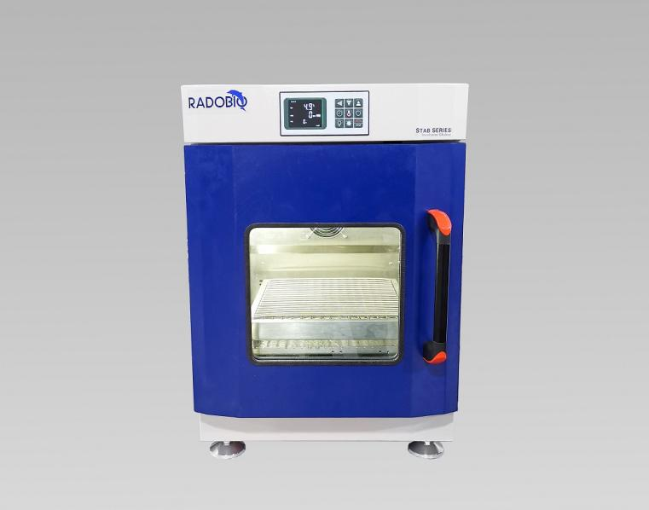
Use for shaking culture of microorganism, it’s UV sterilization incubator shaker.

Key Features：
1, Super mini incubator shaker with cooling function.
2, It runs near silent, and can be stacked to 2 units without any abnormality, effectively saving space.
3, 304 frosted stainless steel arc angle integrated inner cavity, beautiful and easy to clean.
4, Waterproof design and easy-to-clean interior with rounded corners.
5, UV sterilization system, better sterilization effect.
6, Universal net holder is suitable for all kinds of flasks.
7, Double glass door ensures excellent thermal insulation and safety.
8, Circulating airflow technology ensures high consistency of culture conditions in the chamber.
9, After stable operation, if the temperature fluctuation exceeds the set value plus or minus over temperature alarm deviation, audible alarm activates.
10, Audible alarm activates if outer door is opened over 1 minute.

Technical Details
Model | MS70
Interface | Button LCD Control Panel
Rotation speed | 30~300rpm depending on load and stacking
Speed control accuracy | 1rpm
Shaking throw | 26mm
Temperature control mode | PID control mode
Temperature control range | 4°C~60°C
Temperature display resolution | 0.1°C
Temperature fluctuation | ±0.1°C
Temperature field uniformity | ±0.5°C @37°C
Power of heating | 350W
Power of cooling | 450W
Tray size | 380 x 410mm
Maximum load | 15kgs
Tray capacity of shake flask | 16x250ml or 11x500ml or 6x1000ml or 5x2000ml
Timing function | 0-999.9hours
Maximum expansion | Up to 2 units can be stacked
Dimension (W x D x H) | L550 x W648 x H670mm (one unit); L550 x W648 x H1320mm (two units)
Volume | 70L
Illumination | FI tube,30W
Sterilization | UV sterilization
Ambient temperature | 5°C~ 35°C
Power supply | 115V~230V±10%, 50~60Hz
Weight | 70kgs per unit

Configuration List
Incubator Shaker | 1
Shaking Tray with Universal Net Holders | 1
Fuse | 2
Power Cord | 1
Product Manual, Test Report, etc. | 1

